**DATA ANALYTICS WITH TABLEAU**

**1. INTRODUCTION**

**1.1 Overview**

Data analytics converts raw data into actionable insights. It includes a range of tools, technologies, and processes used to find trends and solve problems by using data. Data analytics can shape business processes, improve decision-making, and foster business growth.

As a term, data analytics predominantly refers to an assortment of applications, from basic [business intelligence](https://www.techtarget.com/searchbusinessanalytics/definition/business-intelligence-BI) (BI), reporting and online analytical processing ([OLAP](https://www.techtarget.com/searchdatamanagement/definition/OLAP)) to various forms of [advanced analytics](https://www.techtarget.com/searchbusinessanalytics/definition/advanced-analytics). In that sense, it's similar in nature to [business analytics](https://www.techtarget.com/searchbusinessanalytics/definition/business-analytics-BA), another umbrella term for approaches to analyzing data. The difference is that the latter is oriented to business uses, while data analytics has a broader focus.

The topic of my project is **“Unearthing the Environmental impact of Human Activity: A Global Co2 emission Analysis”**

Global warming is one of the biggest challenges currently being faced by the human race, although correlation is not causation, a likely cause of global warming is due to increased atmospheric carbon dioxide from human activities. **CO2 Emission** refers to the Carbon Dioxide emitted throughout the world. For this analysis we will be focusing on CO2 Emissions and its effect on the world we live in as well as some key factors and stats that may play a role in the emission of CO2 globally. Fossil fuel use is the primary source of CO2. The data throws light onto how much fossil fuels are burnt, per year per nation, which amounts to an increase in CO2 every year. This will help researchers and environment experts to predict global warming. So countries should set a goal to decrease this amount yearly.

**1.2 Purpose**

Tableau is a data visualization tool first and foremost. Therefore, it’s technology is there to support complex computations, data blending and dashboarding for the purpose of creating beautiful visualizations that deliver insights that cannot easily be derived from staring at a spreadsheet. It has climbed to the top of the data visualization heap because of it’s dedication to this purpose.

Creating charts. The simple way to do it is to drag the categories into the 'Row' and 'Column' fields. Let's drag the 'Region' category into the Rows and the 'Sales' Category into Columns. Tableau then automatically creates a bar chart for us.

Using data analytics applications, the companies were able to find the best shipping routes, delivery time, as well as the most cost-efficient transport means. Data analytics is important because it helps businesses optimize their performances. Implementing it into the business model means companies can help reduce costs by identifying more efficient ways of doing business and by storing large amounts of data.

**2. PROBLEM DEFINITION AND DESIGN THINKING**

**2.1 Empathy Map**

**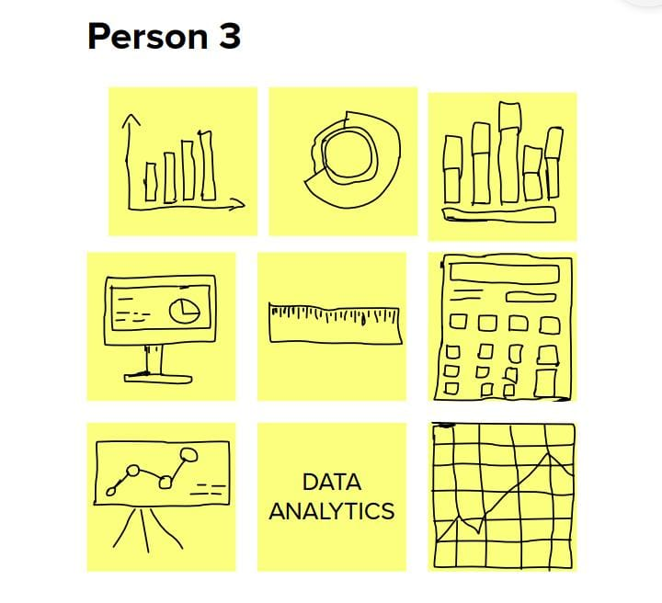

**3. RESULT**

Output of the Project

 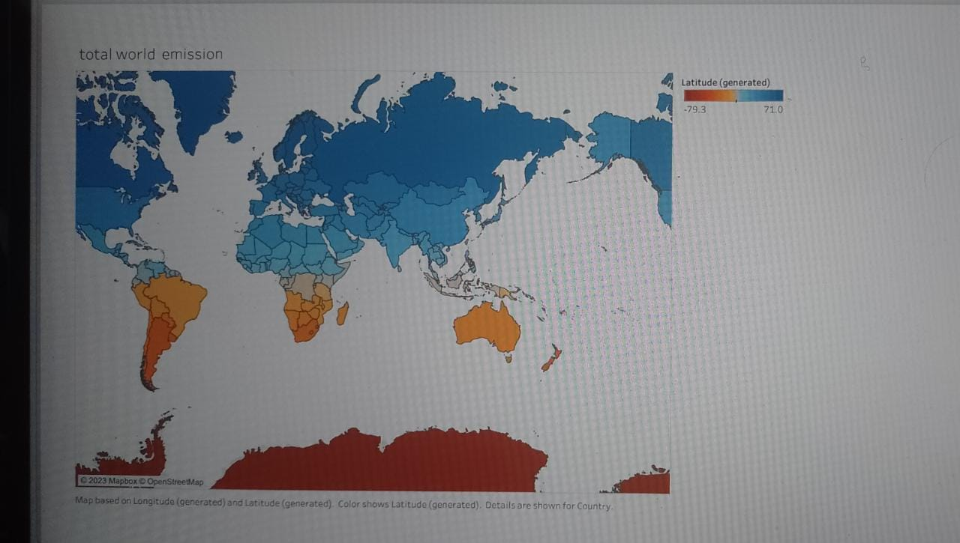

**4. ADVANTAGES AND DISADVANTAGES**

**4.1 Advantages**

Data analytics is a powerful tool every organization can use to improve business operations and increase efficiency. The benefits are two-fold – not only does it help you take better care of your data, but it provides insights into how best to leverage its power for a more significant impact.

It is a process of analyzing data that has revolutionized many industries and will continue to do so in the future.

The days of having to do all your analysis by hand are over! These powerful software tools make it easy and fast. You don’t even need a Ph.D. in statistics anymore- simply enter some data, pick out what matters most from those results, and viola! You’re done with an excellent report that will help grow sales for any company. Using or possessing such information gives you power over entire sectors, allowing for major changes across all societal areas.

Data is the lifeblood of any modern business, but it’s typically in its raw form and doesn’t mean anything. While data analytics offers numerous benefits, it is important to recognize the role of data matching in ensuring the quality and reliability of the information being analyzed. [Data matching use cases](https://winpure.com/data-matching)can be found in various industries such as finance, healthcare, marketing, and government services. By identifying and rectifying data discrepancies, matching techniques help maintain accurate and consistent records, which in turn enable businesses and organizations to draw more meaningful insights from their data. Thus, effective data matching is a crucial component in realizing the full potential of data analytics and its transformative impact on various sectors. That task falls to data analytics- the process that turns this information into meaningful insights used for sound decision-making by companies across industries throughout society as a whole!

There are numerous benefits of data analytics. Some of the benefits are mentioned below.

Product customization: It helps companies make customized offerings according to the market trends, needs, and requirements of customers.

Personalized experience: Through analyzing behavioral patterns of customers, data analytics can be used to provide a personalized experience to customers according to their requirements.

Forecasting: It helps companies predict future trends, so companies are better equipped to deal with any changes in the market.

Gain a competitive advantage: through leveraging data analytics, companies can tailor products according to customers’ requirements and gain insights about market trends that help them make effective strategies. This provides them with a competitive edge in the market.

Increased revenue: The ultimate goal of any organization is to generate revenue. Through data analytics, companies can do an accurate SWOT (strengths, weaknesses, threats, and opportunities) analysis and work on areas in which it is lacking.

**4.2 Disadvantages**

**Lack of alignment within teams**  
There is a lack of alignment between different teams or departments within an organization. Data analytics may be done by a select set of team members and the analysis done may be shared with a limited set of executives. However, the insights generated by these teams are either of not much value or are having limited impact on organizational metrics. This could be due to a “silos” way of working with each team only using their existing processes disconnected from other departments. The analytics team should be focussed on answering the right questions for the business and the results generated by data analytics teams needs to be properly communicated to the right employees to drive the right set of actions and behaviours so that it can have an positive impact on the organization.

**Lack of commitment and patience**  
Analytics solutions are not difficult to implement, however, they are costly, and the ROI is not immediate. Especially, if existing data is not available, it may take time to put processes and procedures in place to start collecting the data. By nature, the analytics models improve accuracy over time and require dedication to implement the solution. Since the business users do not see results immediately, they sometimes lose interest which results in loss of trust and the models fail. When an organization decides to implement data analytics methods, there needs to be a feedback loop and mechanism in place to understand what is working and what is not, and corrective actions are required to fix things that are broken. Without this closed loop system, senior management may decide that analytics is not working or much valuable and may abandon the entire exercise.

**Low quality of data**  
One of the biggest limitations of data analytics is lack of access to quality data. It is possible that companies already have access to a lot of data, but the question is do they have the right data that they need? A top down approach is required where the business questions that need to be answered need to be known first and what data is required to answer these questions can then be determined. In some cases, data may have been collected for historical reasons may not be suitable to answer the questions that we ask today. At other times, even though we have the right metrics that we are collecting data on, the quality of the data collection may be poor. There can be instances where adequate data is not available or is missing for proper analytics to be done. As they say, garbage-in garbage-out. If the data quality is poor, the decision made by using this data is also going to be poor. Hence, actions must be taken to fix the quality of the data before it can be effectively used within organizations.

**Privacy concerns**  
Sometimes, data collection might breach the privacy of the customers as their information such as purchases, online transactions, and subscriptions are available to companies whose services they are using. Some companies might exchange those datasets with other companies for mutual benefit. Certain data collected can also be used against a person, country, or community. Organizations need to be cautious of what sort of data they are collecting from customers and ensure the security and confidentiality of the data. Only the data required for the analysis needs to be captured and if there is sensitive data, it needs to be anonymized so that sensitive data is protected. Data breaches can cause customers to lose trust in the organizations which may result in a negative impact on the organization.

**Complexity & Bias**  
Some of the analytics tools developed by companies are more like a black box model. What is inside the black box is not clear or the logic the system uses to learn from data and create a model is not readily evident. For example, a neural network model that learns from various scenarios to decide who should be given a loan and who should be rejected. The usage of these tools may be easy but the logic of how decisions are made is not clear to anyone within the company. If companies are not careful and a poor quality data set is used to train the model, there may be hidden biases in the decisions made by these systems.

**5. APPLICATIONS**

Not just one or two, the use of data analytics is in every field you can see around. Be it from Online shopping, Hitech industries, or the government, everyone uses data analytics to help them in decision making, budgeting, planning, etc. Data analytics are employed in various places like:

1. Transportation

 Data analytics can be applied to help in improving Transportation Systems and the intelligence around them. The predictive method of the analysis helps find transport problems like Traffic or network congestion. It helps synchronize the vast amount of data and uses them to build and design plans and strategies to plan alternative routes and reduce congestion and traffic, which in turn reduces the number of accidents and mishappenings.  Data Analytics can also help to optimize the buyer’s experience in the travels by recording the information from social media. It also helps travel companies fix their packages and boost the personalized travel experience as per the data collected.

For Example During the Wedding season or the Holiday season, the transport facilities are prepared to accommodate the heavy number of passengers travelling from one place to another using prediction tools and techniques.

2. Logistics and Delivery

There are different logistic companies like DHL, FedEx, etc that use data analytics to manage their overall operations. Using the applications of data analytics, they can figure out the best shipping routes, and approximate delivery times, and also can track the real-time status of goods that are dispatched using GPS trackers. Data Analytics has made online shopping easier and more demandable.

* **Applications of Data Analytics in the Business World**

The use of data analytics in business is not confined internally, Business Analysts direct market examinations, dissecting both product offerings and the general productivity of the business. Furthermore, they create and screen information quality measurements and guarantee business information and detailing needs are met. Business Analysts direct market examinations, dissecting both product offerings and the general productivity of the business. Furthermore, they create and screen information quality measurements and guarantee business information and detailing needs are met.

Tableau is greatly used because data can be analyzed very quickly with it. Also, visualizations are generated as dashboards and worksheets. Tableau allows one to [create dashboards](https://intellipaat.com/blog/tutorial/tableau-tutorial/creating-dashboards/) that provide actionable insights and drive the business forward. Tableau products always operate in virtualized environments when they are configured with the proper underlying operating system and hardware. Tableau is [used by data scientists](https://intellipaat.com/blog/tableau-data-science/) to explore data with limitless visual analytics.

**6. CONCLUSION**

Tableau is a very effective tool for graphical representation, and it has more than 24 different graphical views to display data. Though the dataset is complex or the dataset is very big, in tableau, we can create dashboards very easily and within less time.

 Good data visualization should communicate a data set clearly and effectively by using graphics. The best visualizations make it easy to comprehend data at a glance.

In this Data Analytics project we learned a lot about many applications such as Tableau, My SQL etc., Also we learned how to draw a graph for Data in a easy way with the help of Tableau application.